# Table of Contents

***Tribal Broadband Connectivity***

***Business Plan***

**<** **Tribal Land Name>**

**

*<Release Date>*

Table of Contents 1

1 Executive Summary 4

2 Market Analysis & Coverage Targets 5

2.1 Coverage Targets 5

2.2 Needs Analysis 6

2.3 Competitive Analysis 6

3 Service Offering 7

3.1 Service Description 7

3.2 Sales & Marketing Strategy 7

4 Network Architecture & Dimensioning 8

5 Operating Model 9

5.1 Organization Functions & Structure 9

5.2 Resources 11

6 Project Plan 12

7 Financial Plan 12

7.1 Funding 12

7.2 Financial Projections 12

Annex A. HLD & Financial Model 15

***NOTE TO USERS OF THIS BUSINESS PLAN TEMPLATE***

***Throughout this template, notes and instructions to the Author are provided in red, using the format of this paragraph. Please, review the notes and instructions to the Author and delete all notes and instructions before the Business Plan is shared. It is recommended that these notes are not deleted until the Business Plan is finalized, in the case that changes are made during drafting.***

***[Blue brackets indicate text fields that must be filled out with your own data]***

***This business plan serves as the document of record for the fixed wireless network initiative of the Tribal Land and it can also be utilized to get acceptance or to request funding for the initiative.***

***In order to customize the template for your Tribal Broadband initiative, you’ll need to interact with the Playbook modules and use the outputs obtained through the provided widgets and tools.***

***DELETE THIS PAGE PRIOR TO RELEASING THE BUSINESS PLAN***

# Executive Summary

***[Tribal Land]*** is a federally recognized Tribal Nation located in the state of ***[state’s name]***. The***[Tribal Land]***Reservation comprises approximately***[Tribal Land area in sq km]*** square kilometers. Approximately ***[# of tribe members*],** tribal members live and work on or near the Reservation.

***[Tribal Land]*** has undertaken an effort to stand up a Tribal WISP to deploy and operate a fixed wireless network (“the Network”) to provide broadband service in unserved or underserved areas of the Reservation to residential, commercial, business and institutional users, including Wi-Fi access in public services.

***[Author: edit the paragraph above to match your own scope. In particular confirm if public Wi-Fi will be part of the service offering]***

The target area for coverage is distributed in ***[# of target polygons]*** smaller areas that together represent an area of ***[total area of target polygons]*** square km covering an estimate of ***[total housing units in target polygons]*** homes and ***[sum of estimated covered population]*** inhabitants.

Due to poor or no service offering from fixed and mobile carriers, the Tribal WISP is expected to dominate the market within the target areas.

The Network will be based on ***[LTE/TDMA]*** technology operating in the ***[insert spectrum bands to be utilized]*** GHz spectrum band and will consist of ***[insert number of access sites from the preliminary design]*** access sites plus a core site. This business plan presents the strategy to design, deploy and initiate operations of the Network in a period of ***[Insert number of weeks to execute the project plan]*** weeks.

To do so, the Tribal WISP requires funding for ***[insert total funding requirements]*** which ***[will be obtained from…/are being requested…]***

***[Author: complete the paragraph above explaining how you are planning to get funds for the initiative or if you already have the required funding]***

Total CAPEX to deploy the network and install customers in the first year is ***[Insert CAPEX in the first year]*** and the total CAPEX from year 0 to year 5 is ***[insert the sum of CAPEX from year 0 to year 5]***.

The financial analysis within this business plan shows a positive business case yielding a net present value of ***[insert NPV]*** and an internal rate of return of ***[insert IRR]*** for a hurdle rate of ***[hurdle rate for the financial analysis]***.

The business plan herein, provides an overview of the overall aspects of the project including market analysis, service offering, network architecture, operating model, project plan and financial projections.

# Market Analysis & Coverage Targets

## Coverage Targets

The Tribal WISP will provide coverage in the areas shown in Figure 1. The total target area is ***[sum of the target areas in sq km]*** sq km and covers an estimate of ***[sum of estimated covered homes]*** homes and ***[sum of estimated covered population]*** inhabitants. The information of each individual polygon is provided in Table 1.

***[Insert map showing target polygons]***

Figure 1 – Coverage Targets.

***[Author: Take the data from the Geodemographic tool and paste it in the table below]***

|  |  |  |  |
| --- | --- | --- | --- |
| Polygon | Area [sq km] | Population Estimate | Housing Units Estimate |
|  |  |  |  |
|  |  |  |  |

Table 1 – Coverage Polygons Data

***[Author, from the three options below, select the paragraph that applies to your situation]***

***[Option 1. EBS License, coverage targets meet the 80% requirement from FCC]***

Data in Table 1 utilizes 5-year American Community Survey (ACS-5) census data to calculate estimates ***[Author: update sentence if using other data source]***. Total population within the coverage targets represents ***[percentage of population covered]*** of the population withiin the EBS license area, which meets the 80% population coverage requirement from the FCC.

***[Option 2. EBS License, coverage targets don’t meet the 80% requirement from FCC]***

Data in Table 1 utilizes 5-year American Community Survey (ACS-5) census data to calculate estimates ***[Author: update sentence if using other data source]***. Total population within the coverage targets represents ***[percentage of population covered]*** of the population in the EBS license area, which doesn’t meet the 80% population coverage requirement from the FCC. There will be a second phase of network build to comply with the FCC requirement

***[Option 3. No EBS License]***

Data in Table 1 utilizes 5-year American Community Survey (ACS-5) census data to calculate estimates ***[Author: update sentence if using other data source]***.

In addition, the Fixed Wireless Network will provide coverage to the set of priority targets listed in Table 2.

|  |  |  |  |
| --- | --- | --- | --- |
| Name | Location Type | Latitude | Longitude |
|  |  |  |  |
|  |  |  |  |

Table 2 – Priority Targets Data

## Needs Analysis

The flow of information is as much a utility as the flow of water or electricity. Internet access today is, among others, a fundamental enabler of education, healthcare, social cohesion, public services, and digital inclusion.

We have identified that most of the people living in the target coverage areas lack broadband internet access at their homes and businesses. To get connected, population in these areas ***[Insert the typical way that people access to internet services in the target areas(e.g., drive to a hotspot, pay for mobile access)]***

The following is a list of the needs of our community members and institutions that can be addressed through the Tribal WISP initiative:

* Access to online education and other educational resources
* Home Office
* Telemedicine
* e-Commerce
* Electronic Banking
* Access to news
* Communication (calls, video calls, social media, instant messaging)
* Music & video streaming

***[Author: Edit and augment the list according to the needs and specific use cases in your Community]***

## Competitive Analysis

***[Author, from the two options below, select the paragraph that applies to your situation]***

***[Option 1. Existing competitors]***

Competitors that offer connectivity services within or near to the target areas are described in Table 3.

***[Author: Fill the table with the data from competitors within your target areas, as indicated in the Business Planning module of the Playbook]***

|  |  |  |  |  |
| --- | --- | --- | --- | --- |
| Competitor | Technology  (Fixed Wireless, Fiber, DSL, Cable, Mobile) | Speed  (Mbit/s) | Price  (USD) | Known Issues |
|  |  |  |  |  |
|  |  |  |  |  |

Table 3 – Competitors.

***[Option 2. No competitors]***

There isn’t any wireline, wireless or mobile operators offering connectivity services within or near to the target areas.

Based on the above, the Tribal WISP is expected to dominate the market within the target areas.

# Service Offering

## Service Description

The Tribal WISP will provide the services listed in Table 4 to address the client needs from section 2.2.

***[Author: Fill the table with the characteristics of your services, considering a minimum speed of 25 Mbit/s for downlink and 3 Mbit/s for uplink]***

|  |  |  |  |  |  |
| --- | --- | --- | --- | --- | --- |
| Service Name | Segment  (Residential, SMB, Institutional, Public Wi-Fi) | Download Speed  (Mbit/s) | Upload Speed  (Mbit/s) | Upfront Fee  (USD) | Monthly Price  (USD) |
|  |  |  |  |  |  |
|  |  |  |  |  |  |

Table 4 – Service Plans.

Services will be provisioned using indoor and outdoor customer premises equipment according to the distance from client to the base station.

***[Author: edit the paragraph above according to the type of CPEs considered for your network. Also mention if the CPE cost will be subsidized by the Tribal WISP]***

The monthly fee will be billed based on a ***[prepaid/postpaid]*** scheme.

Clients will be supported through a help desk to resolve issues under an 8x5 service model, considering phone, email, and social networks as contact channels.

***[Author: Edit the paragraph above according to your customer care model]***

## Sales & Marketing Strategy

Clients will be able to contract the Tribal WISP service through the following channels:

***[Author: Describe the ways that a client can contract the service, some of the options are listed below:***

* ***At a tribal community building or central office***
* ***By Phone***
* ***Through the Tribal WISP web page***
* ***At local businesses (distributors)***

***]***

Service payment will be done through…

***[Author: describe the payment methods that will be able to your clients. Some options are through local businesses (distributors), electronic payment, bank deposit, or on-site payment at a community building or central office]***

Marketing strategy will consist of the following actions and programs:

***[Author, edit the marketing methods below, and provide details on the intensity, frequency, and size of the task e.g., “Tribal WISP will host a monthly event during the first year to show residents and business owners the use cases of the broadband access service” or “A sound truck will drive around the target areas every week for the first 4 weeks after the network launch”.]***

* Talks at community meetings and events
* Digital inclusion programs and courses
* Development of the Tribal WISP website
* Radio advertisements
* Printed advertising (posters, billboards, flyers)
* Digital advertising
* Sound truck
* Phone, email, door-by-door

Based on this strategy, the adoption rate and number of subscribers per service has been forecasted for the first five years and is shown in Table 6.

***[Author: fill the table with your own values from the financial model. Add rows as appropriate]***

|  |  |  |  |  |  |  |
| --- | --- | --- | --- | --- | --- | --- |
| Service | | Year 1 | Year 2 | Year 3 | Year 4 | Year 5 |
| Basic | Adoption Rate | 10% | 20% | 35% | 50% | 70% |
| Total Subscribers | 60 | 120 | 210 | 300 | 420 |
|  | Adoption Rate |  |  |  |  |  |
| Total Subscribers |  |  |  |  |  |

Table 5 – Subscriber Forecast

# Network Architecture & Dimensioning

The Network to support the services in section 3.1 will be implemented using ***[LTE/TDMA]*** technology, allowing for microwave (licensed and unlicensed), fiber, and VSAT solutions for backhaul.

***[Author: Remove in the paragraph above backhaul options that are not part of your architecture]***

The mobile core must be implemented under a ***[distributed/centralized]*** architecture.

***[Author: Remove the previous statement if using TDMA technology]***

The high-level E2E network architecture of the Network is shown in Figure 2.

***[Author: Insert the image of your network architecture from the Reference Architecture document obtained through the Network Architecture Wizard]***

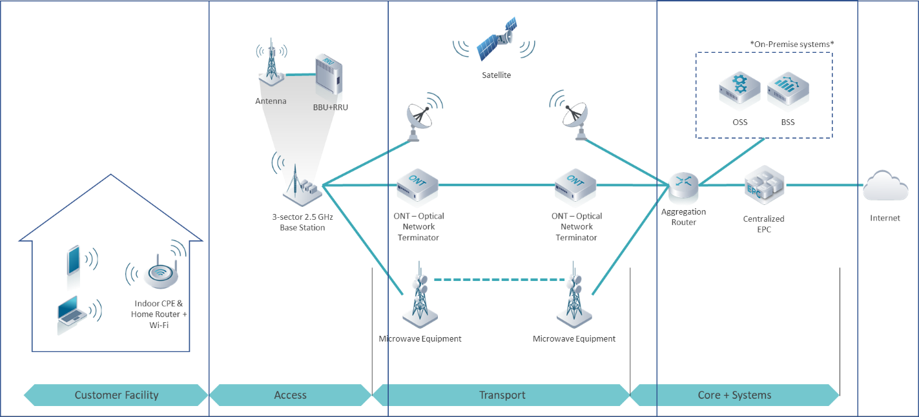

Figure 2 – Fixed Wireless Network Architecture.

The Network will consist of ***[insert number of access sites based on high-level design]*** access sites plus a core site which aggregates the traffic toward a high-speed internet connection. Details on the preliminary high-level network design can be found in Annex A.

# Operating Model

## Organization Functions & Structure

The Tribal WISP will have a lean organization which will be supported through outsourcing specific activities. Table 6 shows the functions to be performed by each area of the organization and the required outsourced support.

***[Author: Fill the table based on your analysis and instructions in the Business Planning Module]***

|  |  |  |
| --- | --- | --- |
| **Area** | **Insourced Activities** | **Outsourced Activities** |
|  |  |  |
| **Engineering** |  |  |
|  |  |
|  |  |
|  |  |
|  |  |
|  |  |  |
| **Deployment** |  |  |
|  |  |
|  |  |
|  |  |
|  |  |
|  |  |  |
| **Operations & Maintenance** |  |  |
|  |  |
|  |  |
|  |  |
|  |  |
|  |  |  |
| **Commercial / Business Development** |  |  |
|  |  |
|  |  |
|  |  |
|  |  |  |
| **Financial & Legal** |  |  |
|  |  |
|  |  |

Table 6 – Operating Model

Organization structure and staffing requirements are detailed in Table 7.

***[Author: Fill the table based on your analysis and instructions in the Business Planning Module]***

|  |  |  |  |
| --- | --- | --- | --- |
| **Position** | **Reports To** | **Management Level** | **Count** |
|  |  |  |  |
|  |  |  |  |
|  |  |  |  |
|  |  |  |  |
| **Engineering** |  |  |  |
|  |  |  |  |
|  |  |  |  |
|  |  |  |  |
| **Deployment** |  |  |  |
|  |  |  |  |
|  |  |  |  |
|  |  |  |  |
| **Operations & Maintenance** |  |  |  |
|  |  |  |  |
|  |  |  |  |
|  |  |  |  |
| **Commercial / Business Development** |  |  |  |
|  |  |  |  |
|  |  |  |  |
|  |  |  |  |
| **Financial & Legal** |  |  |  |
|  |  |  |  |
|  |  |  |  |
| **TOTAL** | | |  |

Table 7 – Organization Structure & Dimensioning

## Resources

Apart from network equipment and systems, critical resources for the Tribal WISP deployment and operation are spectrum, telecom infrastructure, and tools and equipment for network installation and maintenance. The strategy to acquire and utilize these resources is detailed in the sections below.

### Spectrum

***[Author: Edit this section to accurately describe your spectrum strategy]***

Our Tribal Land has ***[obtained/requested]*** a license to operate in the 2.5 GHz educational broadband service (EBS) spectrum. This spectrum will be used along with CBRS spectrum in the 3.5 GHz band and unlicensed spectrum in the 5 GHz band to provide wireless coverage over the target areas in section 2.1.

The strategy to use EBS spectrum consist of covering at least 80% of the population in the license area, as requested by the Federal Communications Commission (FCC).

CBRS spectrum and unlicensed spectrum will be used for areas where the EBS spectrum is not available or additional capacity is required. For CBRS, the Tribal WISP must connect and enter into a commercial agreement with a Spectrum Access System provider.

### Telecom Infrastructure

Infrastructure requirements for the Tribal WISP consist of access sites, backhaul networks, internet connectivity, equipment rooms and the associated supporting infrastructure such as racks, cabinets, and cabling.

***[Author: Explain what your plan for each of the above elements is.***

***Where will the core site be located? At a tribal building or a leased facility from a third party?***

***For access sites, are you planning to lease existing towers, use space in the rooftop of a tribal building, or build new towers?***

***For backhaul, explain if there is an existing backhaul network that can be utilized for this initiative***

***Do you plan to piggy-back on an existing internet connection or to contract the service from a local ISP or major carrier?***

***Do sites have equipment rooms or IT closets? If that’s the case, does it exist cabinets, racks and cabling infrastructure? If not, mention that this is included in the financial plan.]***

### Tools & Equipment

To support the functions defined in section 5.1, a variety of tools and equipment will be required. These tools will be…

***[Author: Explain if the tools will be purchased, if they already exist as part of other Tribal initiatives, or if they will be leased. If considered adequate, you can also describe the set of tools and equipment required]***

# Project Plan

Figure 3 shows the project plan to plan, design, deploy and initiate operations of the Tribal WISP and the associated fixed wireless network. This plan will be completed in ***[Insert number of weeks to execute the project plan]*** weeks based on requirements and assumptions within this document.

***[Author: Insert the Gantt Chart from the provided template]***

Figure 3 – Tribal WISP Project Plan

# Financial Plan

## Funding

The Tribal WISP requires funding for ***[insert total funding requirements in USD]*** which ***[will be obtained from…/are being requested…]***

***[Author: complete the paragraph above explaining how you are planning to get funds for the initiative or if you already have the required funding]***

This amount covers the capital and operational expenses for ***[number of years that funding will support the initiative]*** years, until the revenue increases at an adequate level to provide financial stability to the initiative.

***[We’re requesting funding from… under the terms…]***

***[Author, if you’re requesting funding, use the paragraph above in blue to explain who you are requesting funding from and under which terms]***

## Financial Projections

This section presents the financial analysis for the Tribal WISP, which considers the capital expenditures (CAPEX) to deploy the Network, operating expenditures (OPEX) to run the Network and Revenue from subscriber services.

Details on the preliminary high-level network design that drives CAPEX and OPEX calculations are provided in Annex A.

Total CAPEX in the first year is ***[Insert CAPEX in the first year]*** and the total CAPEX from year 0 to year 5 is ***[insert the sum of CAPEX from year 0 to year 5]***. Figure 4 provides a summary of CAPEX by category from year 0 to year 5.

***[Author: Replace figure with the CAPEX table from your customized financial model]***



Figure 4 – CAPEX Summary

Average OPEX per year is ***[insert average OPEX per year]***. Figure 5 provides a summary of OPEX by category from year 0 to year 5.

***[Author: Replace figure with the OPEX table from your customized financial model]***



Figure 5 – OPEX Summary

Revenue is estimated based on the subscriber forecast in section 3.2 and a stable monthly average revenue per user (ARPU) as established in section 3.1. Revenue per service and total revenue is shown in Figure 6.

***[Author: Replace figure with the Revenue chart from your customized financial model]***

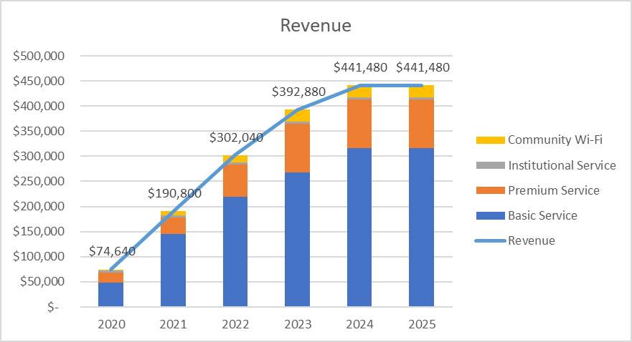

Figure 6 – Revenue Summary

The analysis organizes CAPEX, OPEX and Revenue into a cash flow analysis which renders financial measurements including the present value, net present value (NPV) and the internal rate of return IRR) of the investment. Main assumptions that drive the business plan are listed below:

* Analysis period: ***[insert analysis period]***
* Depreciation period: ***[insert depreciation period / asset lifetime]***
* Tax Rate: ***[insert tax rate, if applicable]***
* Hurdle Rate: ***[insert hurdle rate for discounted cash analysis]***

Figure 7 provides a summary of the financial analysis, showing CAPEX, OPEX, revenue and present value. The NPV for the initiative is ***[insert NPV]*** and the IRR is ***[insert IRR]***.

***[Author: Replace figure with the summary chart from your customized financial model]***

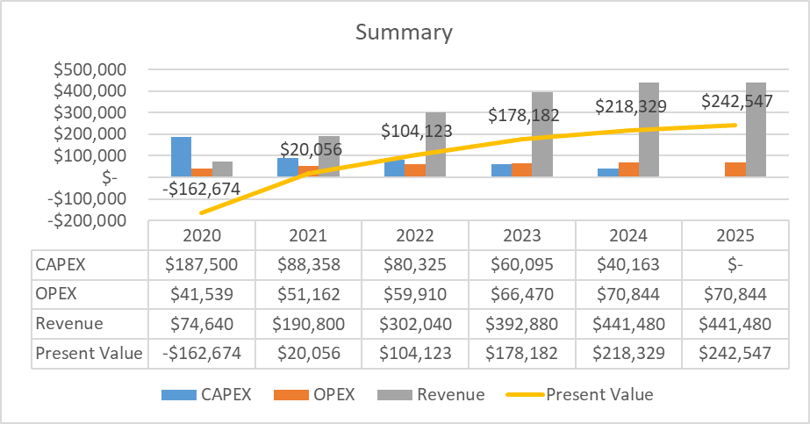

Figure 7 – Financial Analysis Summary

A detailed view of the financial analysis is provided in Annex A.

# Annex A. HLD & Financial Model

The financial model including details of the Network high-level design is embedded in the spreadsheet below:

***[Author, insert the Financial Model as an object to be attached to this document. Use the following options: Insert>Object>Create from File. Further instruction to perform this operation can be found here:*** [***https://support.microsoft.com/en-us/office/insert-a-chart-from-an-excel-spreadsheet-into-word-0b4d40a5-3544-4dcd-b28f-ba82a9b9f1e1***](https://support.microsoft.com/en-us/office/insert-a-chart-from-an-excel-spreadsheet-into-word-0b4d40a5-3544-4dcd-b28f-ba82a9b9f1e1) ***]***